

Semester Two Examination, 2019

Question/Answer booklet

MATHEMATICS

SOLUTIONS
METHODS
UNITS 1 AND 2

Section Two:

Calculator-assumed

Student number: In figures

In words

Your name

Time allowed for this section
Reading time before commencing work: ten minutes
Working time: one hundred minutes

Materials required/recommended for this section
To be provided by the supervisor
This Question/Answer booklet
Formula sheet (retained from Section One)

To be provided by the candidate
Standard items: pens (blue/black preferred), pencils (including coloured), sharpener,
correction fluid/tape, eraser, ruler, highlighters

Special items: drawing instruments, templates, notes on two unfolded sheets of A4 paper, and up to three calculators approved for use in this examination

Important note to candidates
No other items may be taken into the examination room. It is your responsibility to ensure that you do not have any unauthorised material. If you have any unauthorised material with you, hand it to the supervisor before reading any further.

Structure of this paper

Section | Number of questions available | Number of questions to be answered | Working  time (minutes) | Marks available | Percentage of examination
Section One:  Calculator-free | 8 | 8 | 50 | 52 | 35
Section Two:  Calculator-assumed | 13 | 13 | 100 | 98 | 65
 |  |  |  | Total | 100

Instructions to candidates

1. The rules for the conduct of examinations are detailed in the school handbook. Sitting this examination implies that you agree to abide by these rules.

2. Write your answers in this Question/Answer booklet preferably using a blue/black pen.
Do not use erasable or gel pens.

3. You must be careful to confine your answer to the specific question asked and to follow any instructions that are specified to a particular question.

4. Show all your working clearly. Your working should be in sufficient detail to allow your answers to be checked readily and for marks to be awarded for reasoning. Incorrect answers given without supporting reasoning cannot be allocated any marks. For any question or part question worth more than two marks, valid working or justification is required to receive full marks. If you repeat any question, ensure that you cancel the answer you do not wish to have marked.

5. It is recommended that you do not use pencil, except in diagrams.

6. Supplementary pages for planning/continuing your answers to questions are provided at the end of this Question/Answer booklet. If you use these pages to continue an answer, indicate at the original answer where the answer is continued, i.e. give the page number.

7. The Formula sheet is not to be handed in with your Question/Answer booklet.
Section Two: Calculator-assumed 65% (98 Marks)
This section has thirteen (13) questions. Answer all questions. Write your answers in the spaces provided.

Working time: 100 minutes.

Question 9 (6 marks)
(a) Convert $126°$ to an exact radian measure. (1 mark)

Solution
$126×\frac{π}{180}=\frac{7π}{10}$

Specific behaviours
✔ correct value

(b) A segment of a circle of radius $22$ cm is shown below, where $θ=126°$.

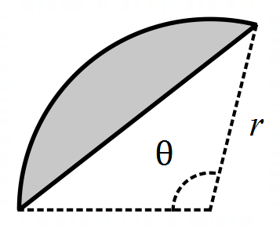

(i) Determine the area of the segment. (2 marks)

Solution
$A=\frac{1}{2}{\left(22\right)}^{2}\left(\frac{7π}{10}-sinsin \frac{7π}{10} \right)≈336.4 {cm}^{2}$

Specific behaviours
✔ indicates correct use of formula
✔ correct area

(ii) Determine the perimeter of the segment. (3 marks)

Solution
Arc length is $L$ and chord length is $C$.

$L=22×\frac{7π}{10}≈48.4$

$C^{2}={22}^{2}+{22}^{2}-2\left(22\right)\left(22\right)coscos 126° C≈39.2P≈48.4+39.2≈87.6 cm$

Specific behaviours
✔ arc length
✔ use of cosine rule for chord length
✔ correct perimeter

Question 10 (8 marks)
From a random survey of telephone usage in $261$ households it was found that $155$ households had access to both mobiles and landlines, $54$ households had no access to a mobile and $145$ more households had landlines than did not.

(a) Complete the missing entries in the table below. (3 marks)

 | Mobile | No mobile | Total
Landline | $155$ | $48$ | $203$
No landline | $52$ | $6$ | $58$
Total | $207$ | $54$ | $261$

Solution
See table
$x+\left(x+145\right)=261⇒x=58$
Specific behaviours
✔ totals column; ✔ totals row; ✔ rest of table

(b) If one household is randomly selected from those surveyed, determine the probability that

(i) it had access to a mobile phone. (1 mark)

Solution
$P\left(M\right)=207÷261≈0.793$
Specific behaviours
✔ correct probability

(ii) it had no access to a landline given that it had access to a mobile. (1 mark)

Solution
$P\left(M\right)=52÷207≈0.251$
Specific behaviours
✔ correct probability

(iii) it had access to a mobile given that it no access to a landline. (1 mark)

Solution
$P\left(\underline{L}\right)=52÷58≈0.897$
Specific behaviours
✔ correct probability

(c) Use your answers above to comment on the possible independence of households having access to a landline and households having access to a mobile phone. (2 marks)

Solution
No indication that the events are independent as $P\left(M\right)≠P\left(\underline{L}\right)$ - would expect these probabilities to be closer if independent.
Specific behaviours
✔ states not independent
✔ justifies by comparing probabilities

Question 11 (7 marks)
A drone is flying in a straight line and at a constant height $h$ m above a level pitch towards a thin goal post. It maintains a constant speed of $4.5$ ms⁻¹.

Initially, the angle of depression from the drone to the base of the post is $8°$. Exactly $3$ seconds later this angle has increased to $10°$.

(a) Sketch a diagram to show the two angles of depression from the drone to the base of the post. (1 mark)

Solution
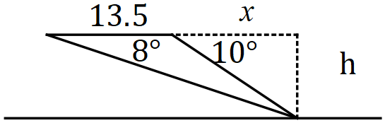

Specific behaviours
✔ sketch with angles

(b) Determine, showing all working, the value of $h$ and calculate the time after leaving its initial position that the drone will collide with the post. (6 marks)

Solution
$d=4.5×3=13.5$

$tantan 8° =\frac{h}{x+13.5}, tantan 10° =\frac{h}{x}$

$\left(x+13.5\right)tantan 8° =xtantan 10° ⇒x=53.018$

$h=53.018×tantan 10° =9.35 m$

$t=\frac{13.5+53}{4.5}=14.8 s$

Specific behaviours
✔ calculates distance travelled
✔ writes equation using trig
✔ writes second equation using trig
✔ solves equations
✔ states $h$
✔ states time

Question 12 (10 marks)
When a manufacturer makes $x$ litres of a chemical using process $X$, the cost in dollars per litre $C(x)$ varies according to the rule

$C\left(x\right)=\frac{240}{x+15}, 5≤x≤45.$

(a) Determine

(i) the cost per litre when $35$ L is made. (1 mark)

Solution
$C\left(35\right)=4.8 \$/L$

Specific behaviours
✔ correct cost per litre

(ii) the total cost of making $17$ L of the chemical. (2 marks)

Solution
$C\left(17\right)=7.5T=7.5×17=\$127.50$

Specific behaviours
✔ cost per litre
✔ correct total cost

(b) Graph the cost per litre over the given domain on the axes below. (3 marks)

Solution (b)
See graph
Specific behaviours
✔ LH endpoint $(5, 12)$
✔ RH endpoint $(45, 4)$
✔ smooth curve through $(15, 8)$ and $(25,6)$
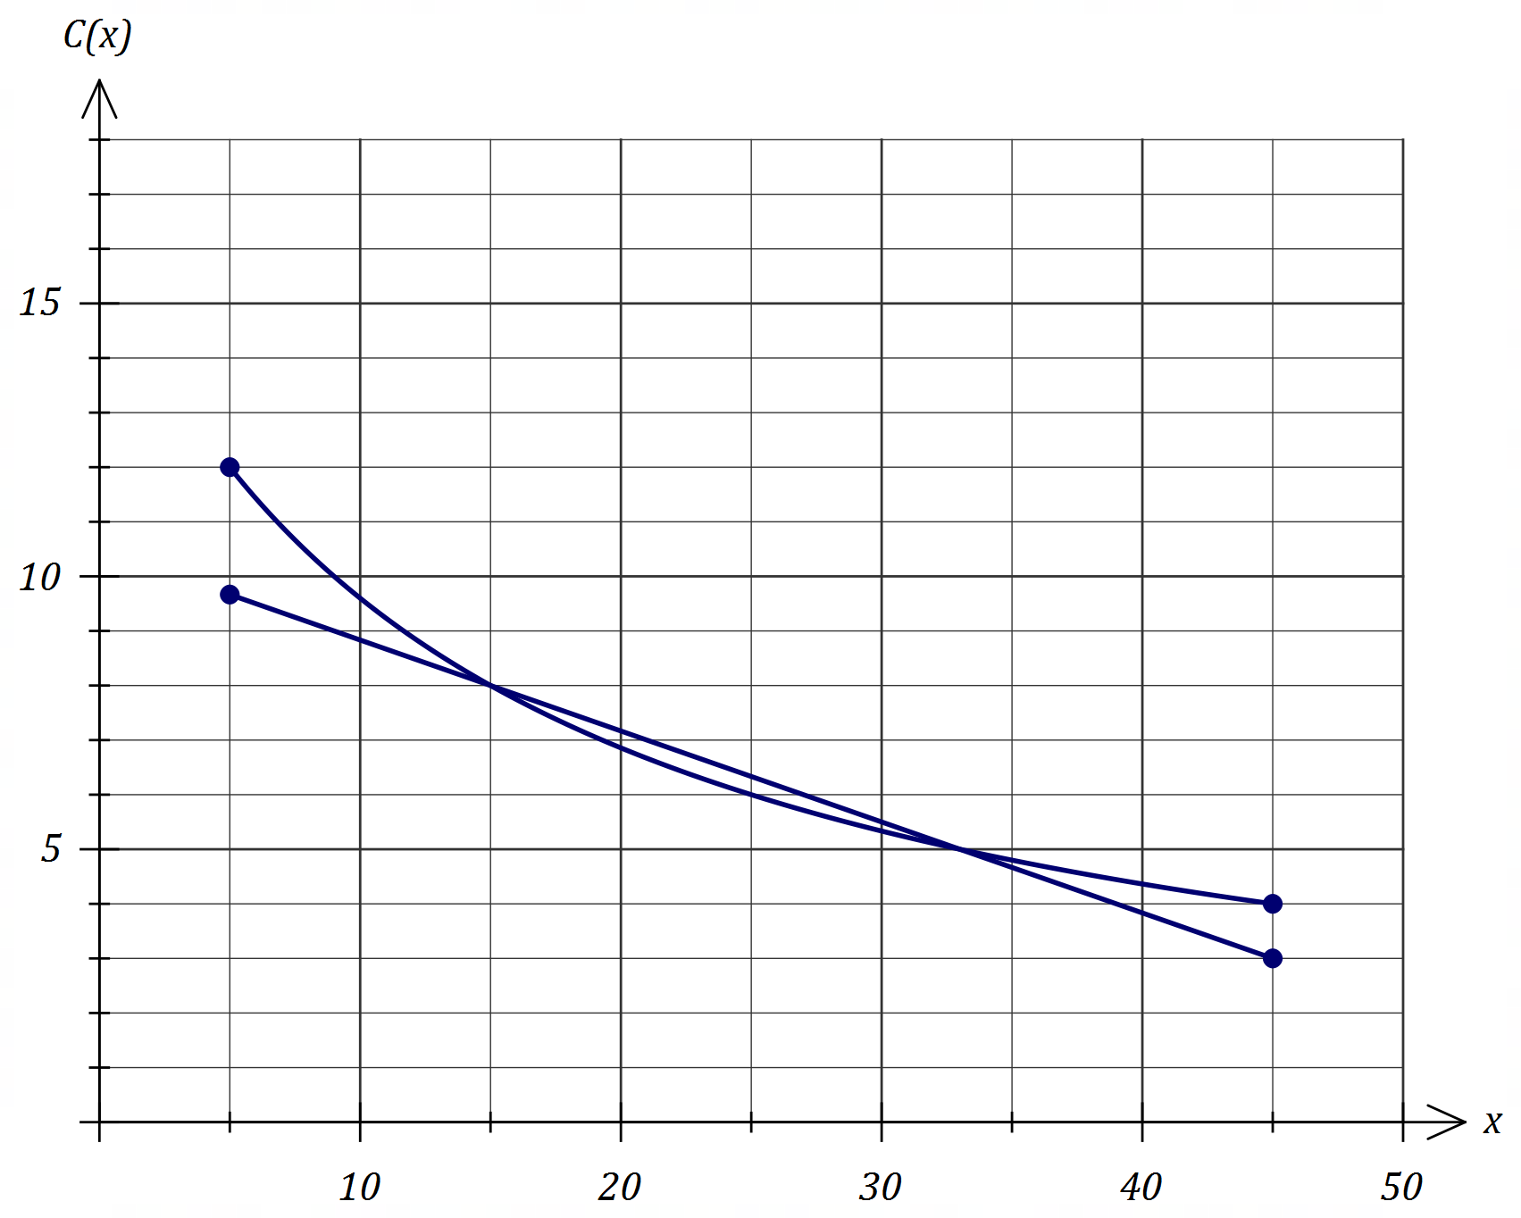

(c) State the range of $C(x)$. (1 mark)

Solution
$4≤C\left(x\right)≤12$

Specific behaviours
✔ correct range

When the manufacturer uses process $Z$, the cost in dollars per litre $K(x)$ is modelled by

$K\left(x\right)=10.5-\frac{x}{6}, 5≤x≤45.$

(d) Add this function to the graph and hence determine the production quantities for which process $X$ is cheaper than process $Z$. (3 marks)

Solution
See graph for line.

Process $X$ is cheaper than $Z$ for $15<x<33$ litres.

Specific behaviours
✔ ruled line through $(15, 8)$ and $(33, 5)$
✔ correct bounds
✔ does not include bounds in answer

Question 13 (7 marks)
The graph of $y=f(x)$ is shown below, where $f\left(x\right)=3^{x}$, together with the secant to the curve through the points $P$ and $Q$.

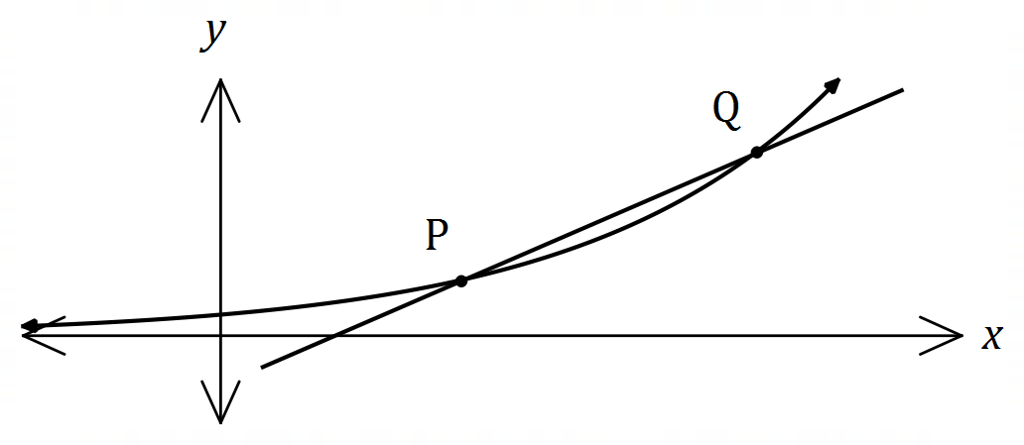

$P$ has coordinates $(1, 3)$ and $Q$ has coordinates $\left(1+h, f\left(1+h\right)\right)$ where $0<h≤1$.

(a) Complete the second column in the table below, rounding values to $4$ decimal places where necessary. (4 marks)

Solution
See table
Specific behaviours
✔ one correct value
✔ three correct values
✔ all correct
✔ last $3$ all to $4$ dp

$h$ | $\frac{f\left(1+h\right)-f(1)}{h}$
$1$ | $6$
$0.1$ | $3.4837$
$0.01$ | $3.3140$
$0.001$ | $3.2976$

(b) Name the feature of the graph above that the values you calculated in part (a) represent.
(1 mark)

Solution
Values are gradient of secant $PQ$ as $Q$ moves closer to $P$.

Specific behaviours
✔ indicates gradient of secant

(c) Determine an estimate, correct to $3$ decimal places, for the value that $f\left(1+h\right)-f(1) \underline{ h }$ approaches as $h$ becomes closer and closer to $0$ and state what this value represents.

Solution
Value approaches $3.296 (3 dp)$.

Value is gradient of curve at $P$.

Specific behaviours
✔ correct value
✔ states value approaches gradient at point
(2 marks)

Question 14 (5 marks)
A geometric sequence has a second term of $-2.5$ and a sum to infinity of $8$.

Determine the sum of the first $3$ terms of the sequence.

Solution
$ar=-2.5, \frac{a}{1-r}=8$

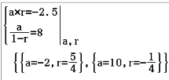

Solving simultaneously gives $a=10, r=-0.25$

(ignore $r=1.25$ since $\left|r\right|<1$ for sum to infinity)

$S_{3}=10+\left(-2.5\right)+\left(-2.5×-0.25\right)=\frac{65}{8}=8.125$

Specific behaviours
✔ equation using $T_{2}$
✔ equation using $S_{∞}$
✔ solves for $a$ and $r$
✔ discards invalid solution
✔ calculates $S_{3}$

Question 15 (12 marks)
The function $f$ is defined by $f(x)=x^{3}+ax^{2}+bx+c$, where $a, b$ and $c$ are constants.

The graph of $y=f(x)$ has the following features:

- passes through $(0, 8)$ and $(-2, 0)$
- has a local minimum at $(2, 0)$

(a) Sketch the graph of $y=f(x)$ on the axes below. (3 marks)

Solution
See graph
Specific behaviours
✔ local minimum
✔ y-intercept and root
✔ smooth curve
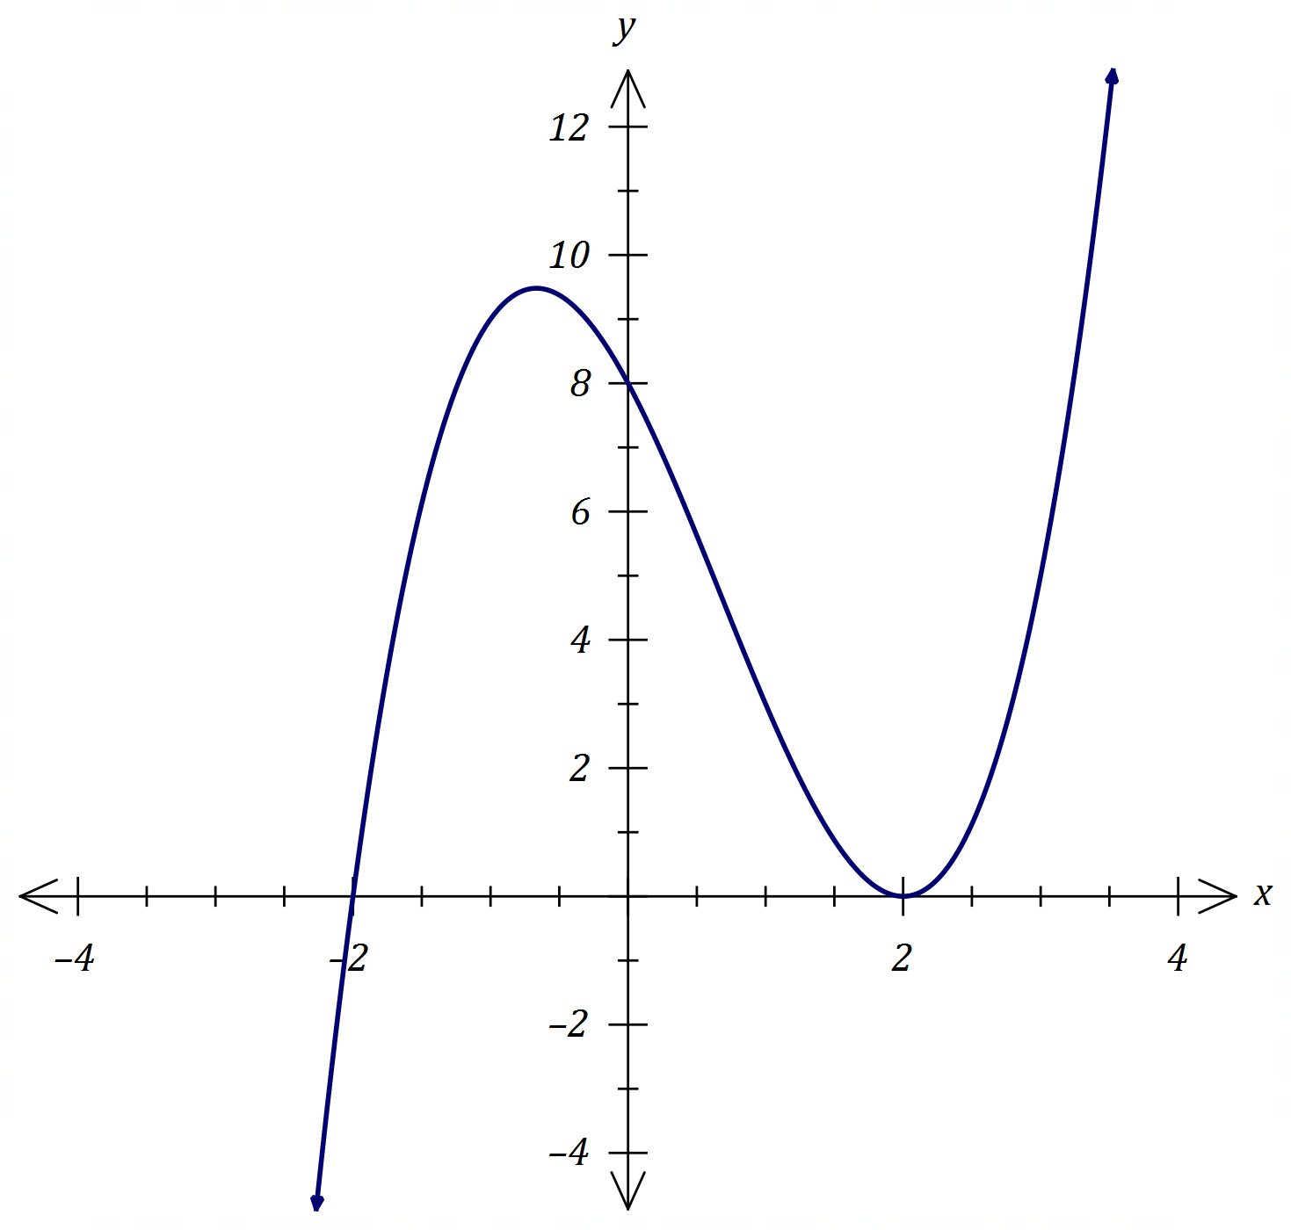

(b) Determine the value of $a$, the value of $b$ and the value of $c$. (3 marks)
Solution
$f\left(x\right)=(x+2){\left(x-2\right)}^{2}=x^{3}-2x^{2}-4x+8$

$a=-2, b=-4, c=8$

Specific behaviours
✔ writes in factored form
✔ expands
✔ states all three values

Solution
$f\left(x\right)=x^{3}+ax^{2}+bx+8$
substituting (-2, 0): $0={(-2)}^{3}+a{(-2)}^{2}+b(-2)+8$
substituting (2, 0): $0={(2)}^{3}+a{(2)}^{2}+b(2)+8$
$a=-2, b=-4, c=8$

Specific behaviours
✔ recognises 8 as y-intercept and subs into equation
✔ sets up simultaneous equations using other points
✔ states all three values

(c) Use a calculus method to determine the exact coordinates of the local maximum of the graph of $y=f(x)$. (3 marks)

Solution
$f^{'}\left(x\right)=3x^{2}-4x-4$

$f^{'}\left(x\right)=0⇒x=2, -\frac{2}{3}$

$f\left(-\frac{2}{3}\right)=\frac{256}{27}$

Local maximum at $\left(-\frac{2}{3}, \frac{256}{27}\right) (-0.\underline{6}, 9.\underline{481})$

Specific behaviours
✔ shows $f'(x)$
✔ shows $f^{'}\left(x\right)=0$ and solutions
✔ correct coordinates

(d) Determine the coordinates of the point where the tangent to $y=f(x)$ at $(0, 8)$ intersects the curve $y=f(x)$, other than at the point of tangency. (3 marks)

Solution
$f^{'}\left(0\right)=-4$

Tangent: $y=-4x+8$

$x^{3}-2x^{2}-4x+8=-4x+8$

$x=0, x=2$

Intersects at $(2, 0)$

Specific behaviours
✔ equation of tangent
✔ equates tangent to curve and solves
✔ correct coordinates

Question 16 (7 marks)
When a patient takes a painkilling drug $A$, the probability that they experience some side effects is known to be $0.1$.

(a) A doctor prescribes drug $A$ to two unrelated patients. Determine the probability that

(i) neither patient experiences some side effects. (1 mark)

Solution
$P={\left(0.9\right)}^{2}=0.81$

Specific behaviours
✔ correct probability

(ii) one patient experiences some side effects and the other does not. (2 marks)

Solution
$P=0.1×0.9×2=0.18$

Specific behaviours
✔ calculates $p(1-p)$
✔ doubles to obtain correct probability

Other painkilling drugs are available. Of those who take drug $A$, $88\%$ of patients who suffer some side effects will switch to another drug whereas no patient who has no side effects will switch.

(b) The doctor prescribes drug $A$ to a patient. Determine the probability that the patient does not switch to another drug. (2 marks)

Solution
$P=0.9+0.1×0.12=0.9+0.012=0.912$

Specific behaviours
✔ probability of side effect and does not switch
✔ correct probability

(c) The doctor prescribes drug $A$ to three unrelated patients. Determine the probability that at least one of these patients switch to another drug. (2 marks)

Solution
$P\left(none\right)={0.912}^{3}≈0.7586P=1-0.7586≈0.2414$

Specific behaviours
✔ probability none switch
✔ correct probability

Question 17 (7 marks)
The amount of water in a tank, $W$ litres, varies with time $t$, in minutes, and can be modelled by the equation $W=200-185{\left(1.2\right)}^{-t}$, $t≥0$.

(a) Determine amount of water in the tank

Solution
$W(0)=15 L$

Specific behaviours
✔ correct value

(i) initially. (1 mark)

Solution
$W(15)=188 L$

Specific behaviours
✔ correct value

(ii) after $15$ minutes. (1 mark)

(b) Graph $W$ against $t$ for $0≤t≤45$ on the axes below. (3 marks)

Solution
See graph
Specific behaviours
✔ $y$-intercept and $(15, 188)$
✔ asymptotic behaviour
✔ smooth curve
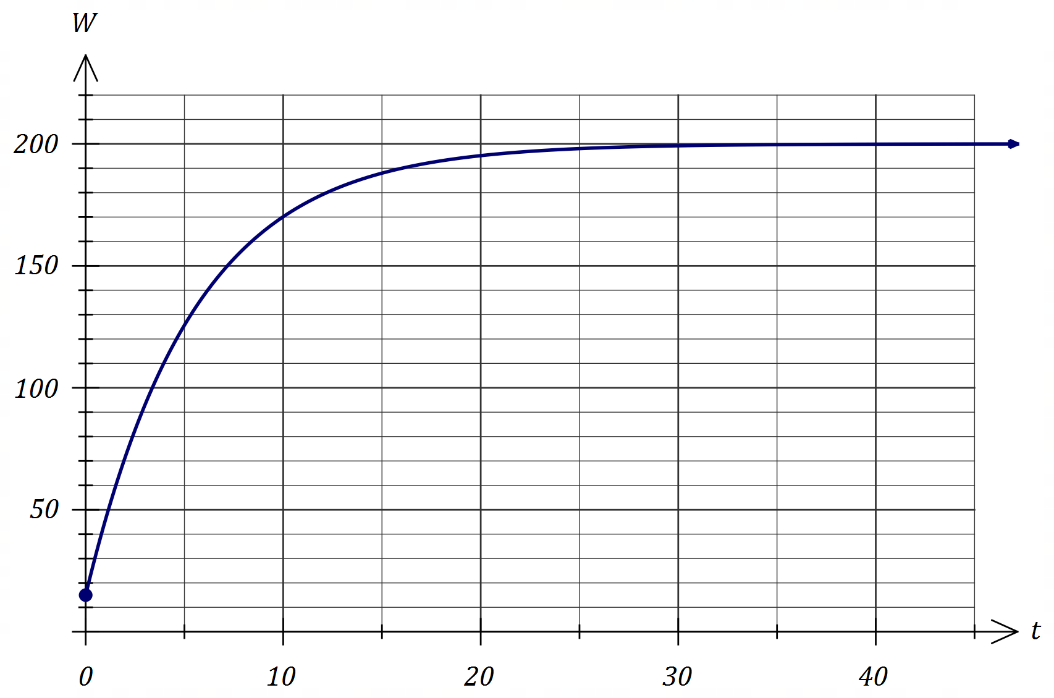

(c) Over time, the amount of water in the tank approaches $v$ litres. State the value of $v$ and determine the time at which the amount of water in the tank reaches $99\%$ of this value.

Solution
$v=200 L$
$W=0.99\left(200\right)⇒t=24.8 minutes$

Specific behaviours
✔ correct value of $v$
✔ correct time
(2 marks)

Question 18 (8 marks)
Two events $A$ and $B$ are such that $P\left(A∩\underline{B}\right)=0.2, P\left(B\right)=0.5$ and $P\left(\underline{A}∩B\right)=x$.

(a) Determine $P(A∩B)$ when $x=0.15$. (2 marks)

Solution
$P\left(A∩B\right)=P\left(B\right)-P\left(\underline{A}∩B\right)=0.5-0.15=0.35$

Specific behaviours
✔ use of Venn diagram or other method
✔ correct probability

(b) Determine an expression for $P(A∩B)$ in terms of $x$. (1 mark)

Solution
$P\left(A∩B\right)=0.5-x$

Specific behaviours
✔ correct expression

(c) Determine the value of $x$ when

(i) $A$ and $B$ are independent. (2 marks)

Solution
$P\left(A∩B\right)=P\left(A\right)×P(B)0.5-x=\left(0.2+0.5-x\right)×0.5x=0.3$

Specific behaviours
✔ uses rule for independence
✔ correct value

(ii) $A$ and $B$ are mutually exclusive. (1 mark)

Solution
$P\left(A∩B\right)=0.5-x=0⇒x=0.5$

Specific behaviours
✔ correct value

(iii) $P\left(A\right)=0.6$. (2 marks)

Solution
$P\left(B|A\right)=\frac{P\left(A∩B\right)}{P\left(A\right)}0.6=\frac{0.5-x}{0.2+0.5-x}x=0.2$

Specific behaviours
✔ uses conditional probability rule
✔ correct value

Question 19 (7 marks)
A right circular cone of base radius $10$ cm and height $25$ cm stands on a horizontal surface. A cylinder of radius $x$ cm and volume $V$ cm³ stands inside the cone with its axis coincident with that of the cone and such that the cylinder touches the curved surface of the cone as shown.

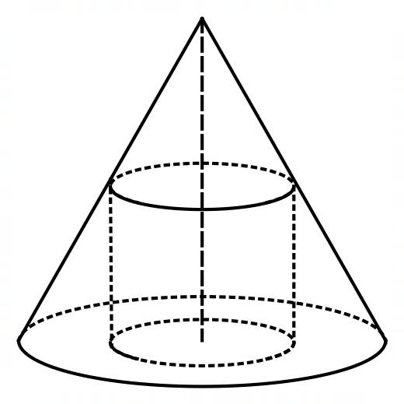

(a) Show that $V=25πx^{2}-2.5πx^{3}$. (3 marks)

Solution
From similar triangles
$\frac{h}{10-x}=\frac{25}{10}⇒h=25-2.5x$
Hence
$V=πr^{2}hV=πx^{2}\left(25-2.5x\right)=25πx^{2}-2.5πx^{3}$

Specific behaviours
✔ relation between $x$ and $h$ using similar triangles
✔ expresses $h$ in terms of $x$
✔ substitutes into cylinder volume formula

(b) Given that $x$ can vary, use a calculus method to determine the maximum value of $V$.

Solution
$\frac{dV}{dx}=50πx-7.5πx^{2}$

$\frac{dV}{dx}=0 when x=0, x=\frac{20}{3}$

$x=0⇒V=0 (maximum)$

$x=\frac{20}{3}⇒V=\frac{10 000π}{27}≈1164 {cm}^{3} (maximum)$

Specific behaviours
✔ derivative
✔ equates derivative to $0$
✔ solves for $x$
✔ states maximum volume
(4 marks)

Question 20 (8 marks)
A fair six-sided dice numbered $1, 2, 3, 4, 5$ and $6$ is thrown $n$ times until it lands on a $6$.

(a) Show that the probability that $n=3$ is $25 \underline{216}$ . (1 mark)

Solution
$P(n=3)=\frac{5}{6}×\frac{5}{6}×\frac{1}{6}=\frac{25}{216}$

Specific behaviours
✔ shows product of three fractions

(b) Determine the probability that $n=5$. (1 mark)

Solution
$P\left(n=5\right)={\left(\frac{5}{6}\right)}^{4}×\frac{1}{6}=\frac{625}{7776}≈0.0804$

Specific behaviours
✔ correct probability

(c) Write an expression in terms of $n$ for the probability that the first $6$ is thrown on the $n$^{th} throw and explain why the probabilities form a geometric sequence. (2 marks)

Solution
$P=\frac{1}{6}{\left(\frac{5}{6}\right)}^{n-1}$
The expression takes the form of the $n$^{th} term of a GP - $a{\left(r\right)}^{n-1}$
Specific behaviours
✔ correct expression
✔ compares to general term of GP

(d) Determine the probability that the first $6$ is thrown in $12$ or less attempts. (2 marks)

Solution
$S_{12}=\frac{\frac{1}{6}\left(1-{\left(\frac{5}{6}\right)}^{12}\right)}{1-\frac{5}{6}}≈0.8878$

Specific behaviours
✔ indicates use of sum formula
✔ correct probability

(e) The probability that the first $6$ is thrown in $k$ or less attempts must be at least $99\%$. Determine the least value of integer $k$. (2 marks)

Solution
$0.99=\frac{\frac{1}{6}\left(1-{\left(\frac{5}{6}\right)}^{n}\right)}{1-\frac{5}{6}}⇒n=25.3k=26$
Specific behaviours
✔ solves for $n$
✔ correct value of $k$

Question 21 (6 marks)
The graphs of $y=f(x)$ and $y=g(x)$ are shown below where $f\left(x\right)=1+4x-2x^{2}$ and
$g\left(x\right)=2x+k$.
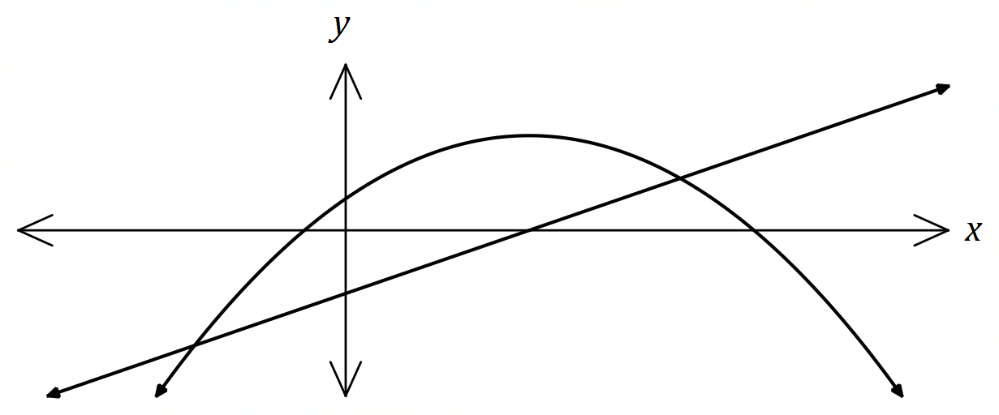

Determine the value(s) of the constant $k$ so that the equation $f\left(x\right)=g(x)$ has

(a) one solution. (5 marks)

Solution
$g$ must be a tangent to $f$:

$f^{'}\left(x\right)=4-4x=2 when x=\frac{1}{2}$

$y$-coordinate of point of tangency:
$f\left(\frac{1}{2}\right)=1+4\left(\frac{1}{2}\right)-2{\left(\frac{1}{2}\right)}^{2}=\frac{5}{2}$

Equation of tangent:
$y-\frac{5}{2}=2\left(x-\frac{1}{2}\right)y=2x+\frac{3}{2}$

Hence $k=\frac{3}{2}=1.5$

Specific behaviours
✔ indicates tangent required
✔ determines $x$-coordinate of point of tangency
✔ determines $y$-coordinate of point of tangency
✔ equation of tangent
✔ states correct value of $k$

(b) no solutions. (1 mark)

Solution
$k>1.5$

Specific behaviours
✔ correct inequality

Supplementary page

Question number: _________

Supplementary page

Question number: _________

© 2019 WA Exam Papers. Kennedy Baptist College has a non-exclusive licence to copy and communicate this document for non-commercial, educational use within the school. No other copying, communication or use is permitted without the express written permission of WA Exam Papers. SN245-142-4.

